# Stress tests report

Authors:

Georgi Chishirkov

Chiel Zelders

Preslav Gerchev

### 1. Stress test on entire website crawl

**1.1 Setup with quick explanation**

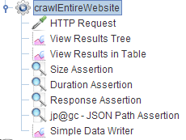

Going from top to bottom.

crawlEntireWebsite – thread group that specifies how many users (threads) will execute the below specified actions for a period of time

HTTP request – specifies the type of requests we are sending and to which domain (with added paths and parameters)

View Results – 2 ways to view the generated results

Assertion types:

Size – checks if the responses we get are a specified size (if != 3811 bytes, fail)

Duration – checks if a response has taken a longer time than specified (if <2000ms, fail)

Response – checks the response code (if !=200, fail)

JSON Path Assertion – check if the response is in JSON format by checking a path-value pair (if != JSON, fail)

**1.2 Generated report and results**

Results in Tree format.

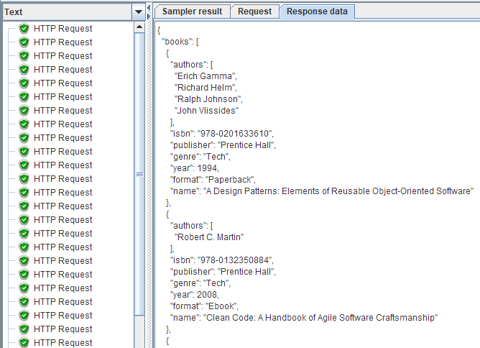

Generated report

From multiple running tests we concluded that the API can handle only 1 request for every 1200 ms (on average).

### 2. Stress test on finding a single item

**2.1 Setup and quick explanation**

The setup structure (for the showcased test) is identical to the first stress test but containing different values and sending a higher frequency of requests.

Assertion types:

Size – checks if the responses we get are a specified size (if != 176 bytes, fail)

Duration – checks if a response has taken a longer time than specified (if <2000ms, fail)

Response – checks the response code (if !=200, fail)

JSON Path Assertion – check if the response is in JSON format by checking a path-value pair (if != JSON, fail)

**2.2 Generated reports and result**

Results in Tree format

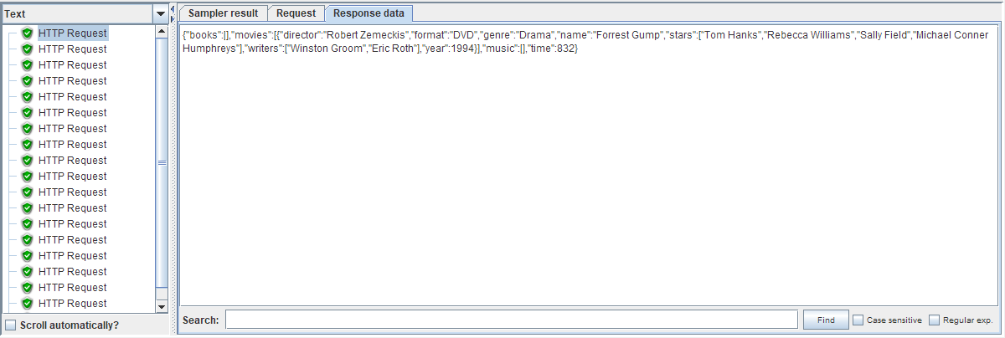

Generated report

From multiple running tests we concluded that the API can handle only 1 request for every 1000 ms (on average).